Output Screenshots
Maven workflow file configured in GitHub Actions:
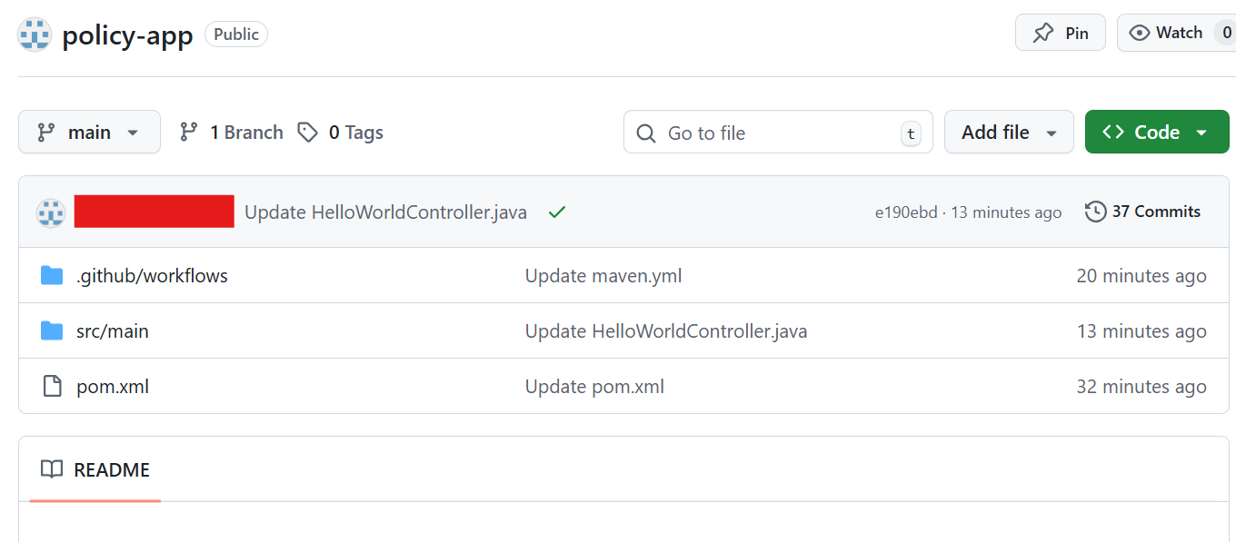
Tomcat Apache setup:

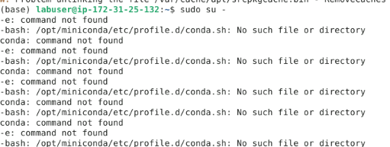

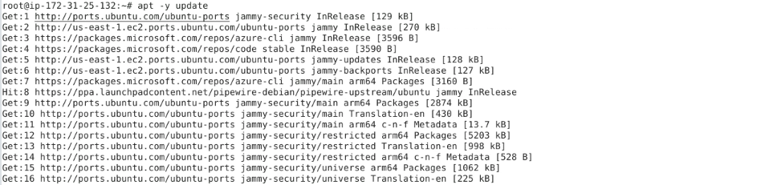
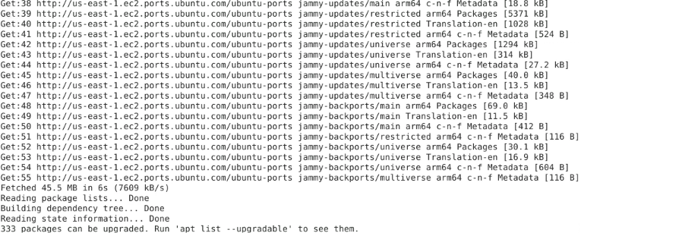

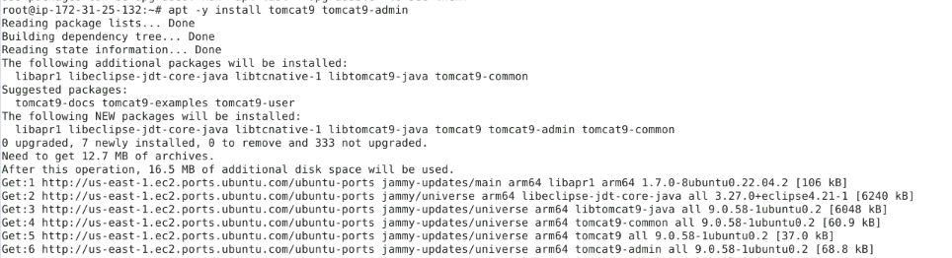
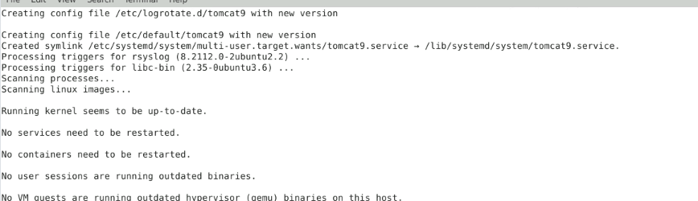

SSH pipeline configuration in maven.yml workflow file:
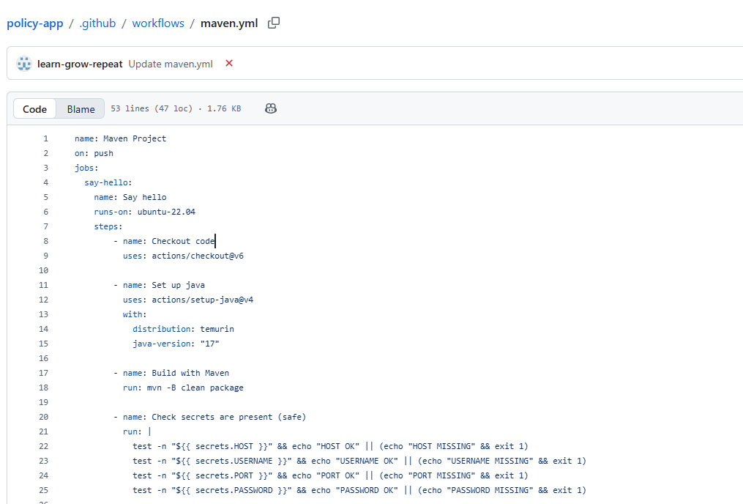

Workflow configuration to integrate Jenkins and GitHub Actions:

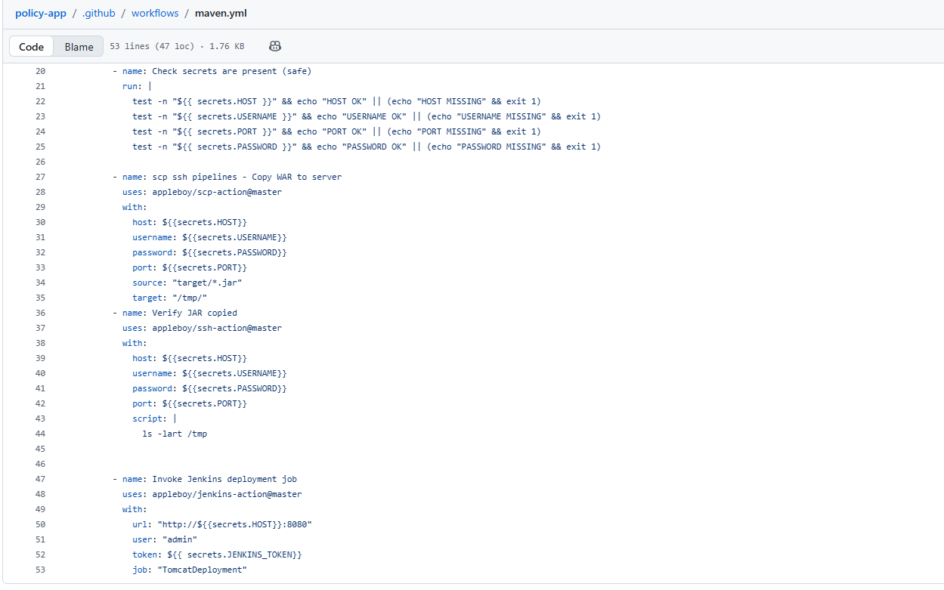

GitHub repository secrets:
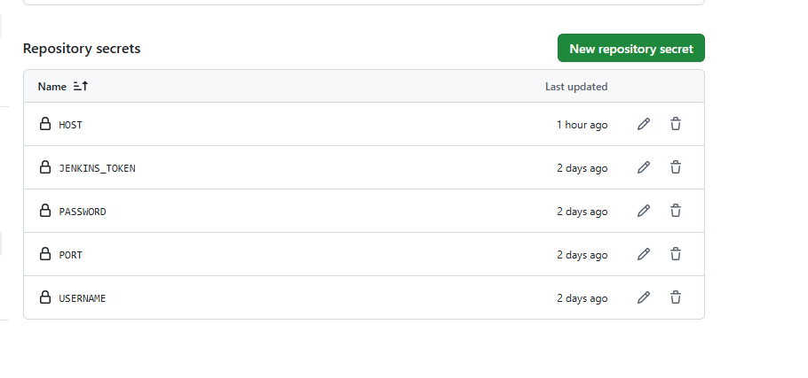
Jenkins job being invoked from the GitHub Actions pipeline for continuous deployment:
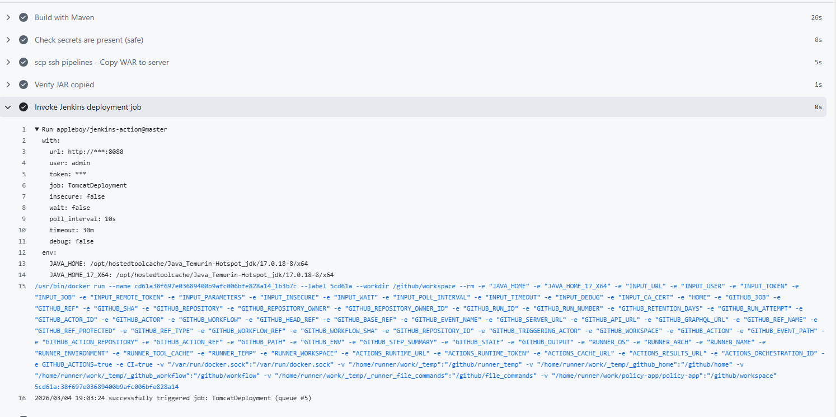

Freestyle job creation in Jenkins for continuous deployment:
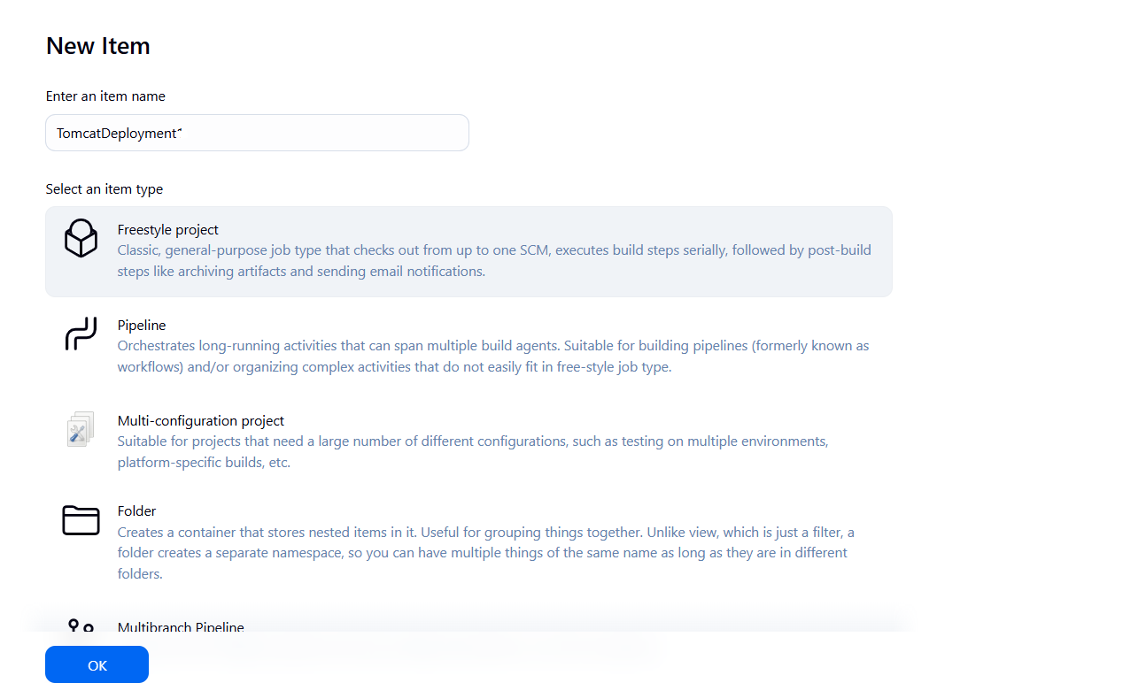

Deployment of the Java application on Tomcat by invoking Jenkins job from a GitHub Actions pipeline:
